iion SDK ironSource Custom Adapter

What is a custom adapter?

Custom adapters enable you to integrate any SDK network you want in your mediation stack through ironSource mediation. This means you can serve ads from any other networks that are right for your audience, in addition to all the networks available through the ironSource mediation.

Your new network will look like a native part of the ironSource platform on the SDK Networks Setup, Mediation Management page, and in your monetization reports. You can also use the same features you use for certified networks for your new network, including segments, A/B testing, sort by eCPM, and more.

The minimum supported ironSource mediation SDK versions is 7.1.14.

Step 1: iion SDK Custom Adapter Integration

1. Unzip the iion SDK package and find the custom adapter files under the “IronSource Custom Adapter” folder.

1. Copy the adapter java file under the path: com.ironsource.adapters.custom.iion. Please make sure the adapter files are placed under the correct path in your app.

1. AAR/JAR library file integration

Copy the iion…*.aar from the SDK compression package to Application Module/libs folder (If not exist, create manually), then add the following codes to build.gradle in your Module app：

//In Unity, the application folder is exported as unityLibrary

repositories {

flatDir {

dirs 'libs'

}

}

dependencies {

compile(name: 'iion.*.*.*', ext: 'aar') //replace with the specific sdk version number

}

1. ProGuad Configuration (Recommended)

Add to the following codes to the .pro file under the APP folder (For Android, the file is usually exported as proguard-rules.pro. For Unity, the file is exported as proguard-unity.txt):

-keep class com.iion.** {*;}

-keep class com.admob.custom.adapter.** {*;}

-keep class com.ironsource.adapters.** {*;}

-keep class com.applovin.mediation.adapters.** {*;}

Step 2: Register iion as your custom adapter

Register iion as your custom adapter and get the network key.

[ironSource | Custom adapter registration](https://ironsrc.formtitan.com/Custom-Adapter)

Some information required in the register form:

* Network details – Network Name: iion
* Network details – Network Name (abbrev.*): iion
* Network Contact Person: Please get the info from your iion Account Manager
* Contact Email: Please get the info from your iion Account Manager
* Company Name: Please get the info from your iion Account Manager
* Company Address: Please get the info from your iion Account Manager
* Country: Please get the email from your iion Account Manager
* Account level: sid, token
* App level: appid
* Instance level: unitid

Once you submit the form, you will get the below information **immediately** on the page. **Make sure you save it since it includes important information for you to set up your adapters. The new network key might need several minutes before taking effect.**

Step 3: Get Network Setup Parameters

Before adding the iion as a custom network to your ironSource mediation, please reach out to your iion Account Manager to get the parameters you need for setting up in ironSource dashboard.

Below are the parameters you'll need:

|  |  |  |
| --- | --- | --- |
|  | Parameters Required by ironSource | Parameters Defined by iion |
| Account Level Parameter | sid | ID |
| Account Level Parameter | token | Token |
| App Level Parameter | appid | APP ID |
| Ad Instance Parameter | unitid | Placement ID |

Step 4: Configure the ad network account settings at ironSource

1. Log in to your ironSource account and go to Monetize ➣ Setup ➣ SDK Networks. Website: ironSource (is.com)
2. Click Manage Networks and select Custom Adapter at the end of the list. (If not visible, please contact your ironSource account manager to enable this for you)

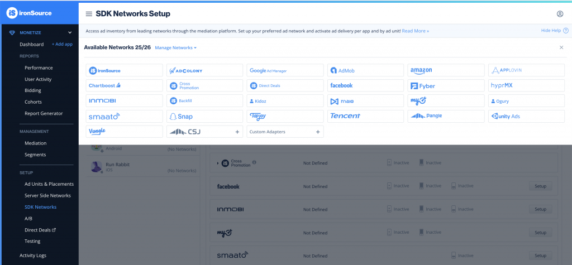

1. Enter the iion network key you just applied.

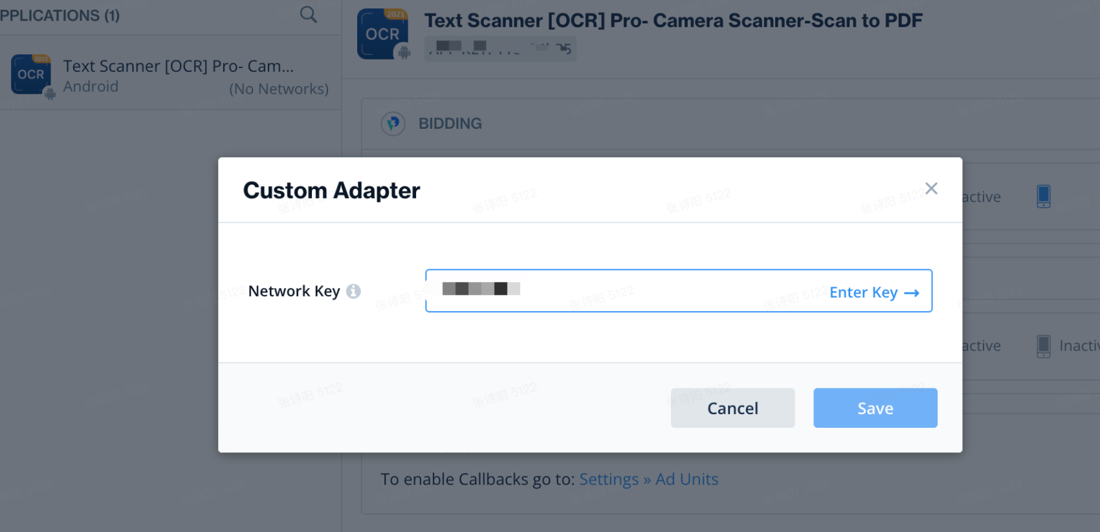

1. Once the network key is recognized, you’ll be able to see iion in the name field. Enter the required account level parameters such as sid and token, which are defined by iion.

Step 5: App level setup

On the left-hand side of the SDK Networks Setup page, you will see the list of apps in your ironSource account. Select the relevant app, and scroll down to the Custom section to find the newly defined network. Click Setup to complete the network’s configuration.

1. Configure the network’s app and ad unit you want to serve based on your network’s settings.

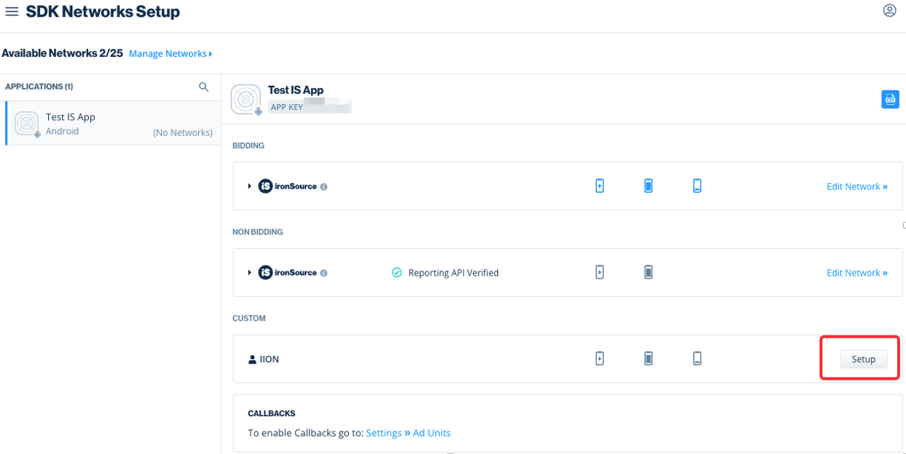

1. Make sure to define Mediation Groups and Rate for each instance.

Use Mediation Groups to define specific instances per specific countries.

Use Rate to assign a price to an instance to make sure it delivers in the order you want in your waterfall. Learn more about rate [here](https://developers.is.com/ironsource-mobile/general/instance-rate-2).

* *Enter appid and unitid*

* *Once done, you'll see iion is added. Make sure the status is "Active."*

Step 6: Testing

The last step is testing if the iion adapter is working well. Place the iion instance at the proper place within your mediation and make sure iion has a chance to receive ad requests.

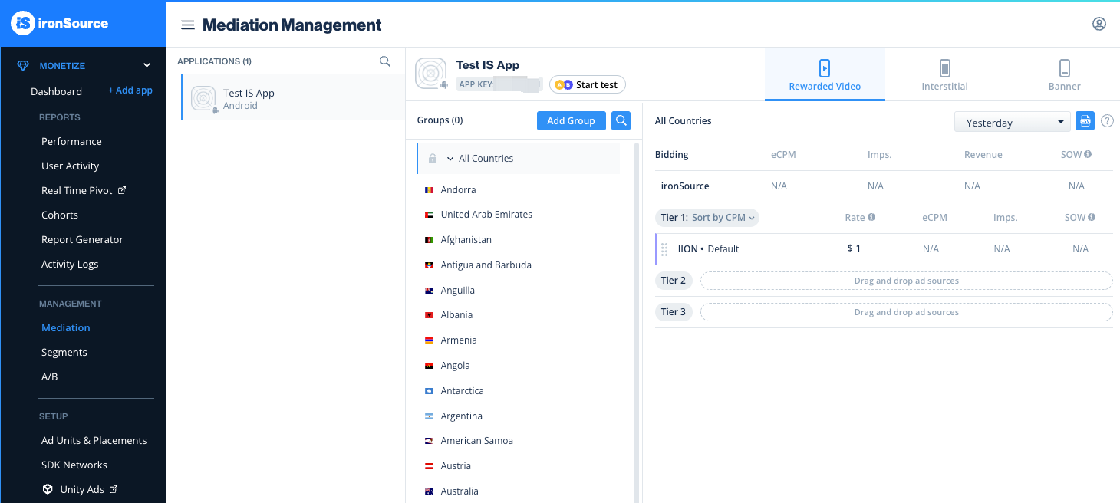

If you need to test with the test device, please follow the ironSource integration testing process especially for the mediation testing part.

[Integration Testing - IronSource Knowledge Center](https://developers.is.com/ironsource-mobile/air/integration-testing)

Done

You’ve completed your custom adapters setup on the ironSource platform. If you have any questions about setting up the custom adapter, please contact your iion Account Manager.